**Practical no:7**

a.Demonstrate javascript objects such as Strings/Regular expression/Math/Date.

b.Demonstrate javascript objects such as window/Navigator/History/location/document

Program:

a.

1.string

<!DOCTYPE html>

<html>

<head>

<title>Sample HTML</title>

</head>

<body>

<script>

var str1 = "Hey diddle, the cat and the fiddle. The cow jumped over the moon.";

var str2 = "The little dog laughed to see such fun, and the dish ran away with the spoon!";

document.write(str1 + "<br>" + str2 + "<br>");

var y = 'We are the so-called "Vikings" from the north.';

var str1Length = str1.length;

document.write("<br>" + "Length of string is " + str1Length + "<br>");

var x = 'It\'s alright';

document.write("<br>" + x + "<br>");

document.write("<br>" + y + "<br>");

</script>

</body>

</html>

Op:

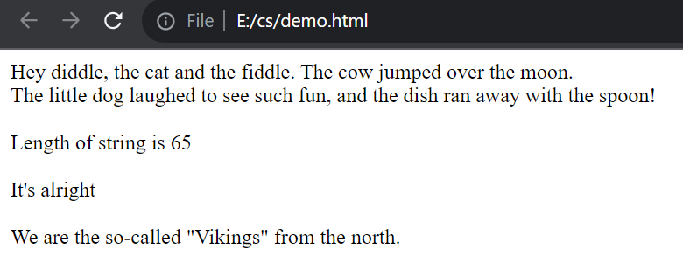

2.regular expression

<!DOCTYPE html>

<html>

<head>

<title>Regular Expression Example</title>

</head>

<body>

<p>REGULAR EXPRESSION</p>

<button onclick="myFunction()">Click</button>

<script>

function myFunction() {

var str = "All these are not possible using HTML!";

var n = str.search(/possible/i);

document.write("<br>" + n + "<br>");

var res = str.replace(/possible/i, "POSSIBLE");

document.write("<br>" + res + "<br>");

var patt = /e/;

document.write("<br>" + patt.test(str) + "<br>");

}

</script>

</body>

</html>

Op:

 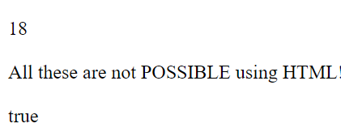

3.Math

<!DOCTYPE html>

<html>

<head>

<title>JavaScript Math Demo</title>

</head>

<body>

<h2>JavaScript Math Demo</h2>

<script type="text/javascript">

document.write("PI=" + Math.PI + "<br>");

document.write("random number " + Math.round(Math.random() * 10) + "<br>");

document.write("rounding " + Math.round(6.433) + "<br>");

document.write("pow=" + Math.pow(10, 3) + "<br>");

document.write("square root=" + Math.sqrt(64) + "<br>");

document.write("absolute=" + Math.abs(-67.7) + "<br>");

document.write("ceil=" + Math.ceil(6.4) + "<br>");

document.write("floor " + Math.floor(4.7) + "<br>");

document.write("sin=" + Math.sin(90 * Math.PI / 180) + "<br>");

document.write("cos=" + Math.cos(0 * Math.PI / 180) + "<br>");

document.write("finding max=" + Math.max(0, 150, 30, 20, -8, -200) + "<br>");

document.write("finding min=" + Math.min(0, 150, 30, 20, -8, -200) + "<br>");

</script>

</body>

</html>

Op:

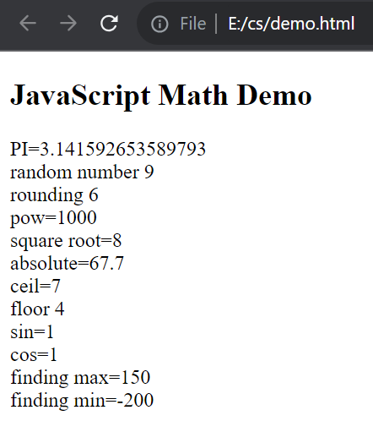

4.Date

<!DOCTYPE html>

<html>

<head>

<title>Date Demonstration</title>

</head>

<body>

<h2>Date Demonstration</h2>

<script>

document.write(Date());

var d = new Date();

document.write("<br>" + d + "<br>");

var d1 = new Date("August 30, 2004 17:11:00");

var d2 = new Date(45400000);

document.write("<br>" + d1 + "<br>");

document.write("<br>" + d2 + "<br>");

var d3 = new Date(99, 5, 24, 11, 33, 30, 0);

document.write("<br>" + d3 + "<br>");

var d4 = new Date(99, 5, 24);

document.write("<br>" + d4 + "<br>");

document.write("<br>d.toUTCString() " + d.toUTCString());

</script>

</body>

</html>

Op:

